# How it works

Reference: <https://learn.microsoft.com/en-us/dynamics365/supply-chain/service-management/specify-how-to-dispose-of-returned-items>.

Sorted by level of physical and financial updated.

|  |  |  |  |
| --- | --- | --- | --- |
| **Disposition action** | **Description** | **Physical update** | **Financial update** |
| Return to customer | Reject the returned item and return it to the customer. | Nothing.  A new line will be added to the same return order which means the item is returned back to the warehouse then it is sent back to the customer after inspection.  Two inventory transactions (for the return action and the send-back action) will offset each other and cause no inventory change. Nevertheless, the return and send-back action can be done separately (posting delivery note and invoicing).  No quarantine order is created for this action. | Nothing. |
| Credit only | Credit the customer without requiring or expecting the item to be returned. | Nothing. | Credit the amount to the customer. |
| Credit | Return the item to inventory and credit the customer. | A new inventory transaction will be created.  Item is purchased back to the inventory. | Credit the amount to the customer. |
| Scrap | Scrap the item and credit the customer. | A new inventory transaction will be created.  Item is purchased back to the inventory.  A new quarantine order will be created as the inspection. After inspection, the item will be scrapped. Another inventory transaction will be created to deduct the item from the inventory. | Credit the amount to the customer. |
| Replace and credit | Return the item to inventory, create a replacement order, and credit the customer. | A new inventory transaction will be created.  Item is purchased back to the inventory.  ~~A new quarantine order will be created as the inspection. After inspection, the item will be scrapped. Another inventory transaction will be created to deduct the item from the inventory.~~  At the same time, a replacement order is required. If no replacement order is created prior to the return item receiving, an error message will be thrown.  Up-front replacement can be made or a placeholder for the replacement can be made on the line. | Credit the amount to the customer.  Charge the customer for the replacement item. |
| Replace and scrap | Scrap the item, create a replacement order, and credit the customer. | A new inventory transaction will be created.  Item is purchased back to the inventory.  A new quarantine order will be created as the inspection. After inspection, the item will be scrapped. Another inventory transaction will be created to deduct the item from the inventory.  At the same time, a replacement order is required. If no replacement order is created prior to the return item receiving, an error message will be thrown.  Up-front replacement can be made or a placeholder for the replacement can be made on the line. | Credit the amount to the customer.  Charge the customer for the replacement item. |

# New customisation/extension

BRAN form now will start from the latest BRAN instead of the oldest upon entering the form.

Upon creating a replacement item on the Return order line, this message will show up. This is for better visibility because there’s no messages by default; yet, at this moment, no actual replacement order has been created.

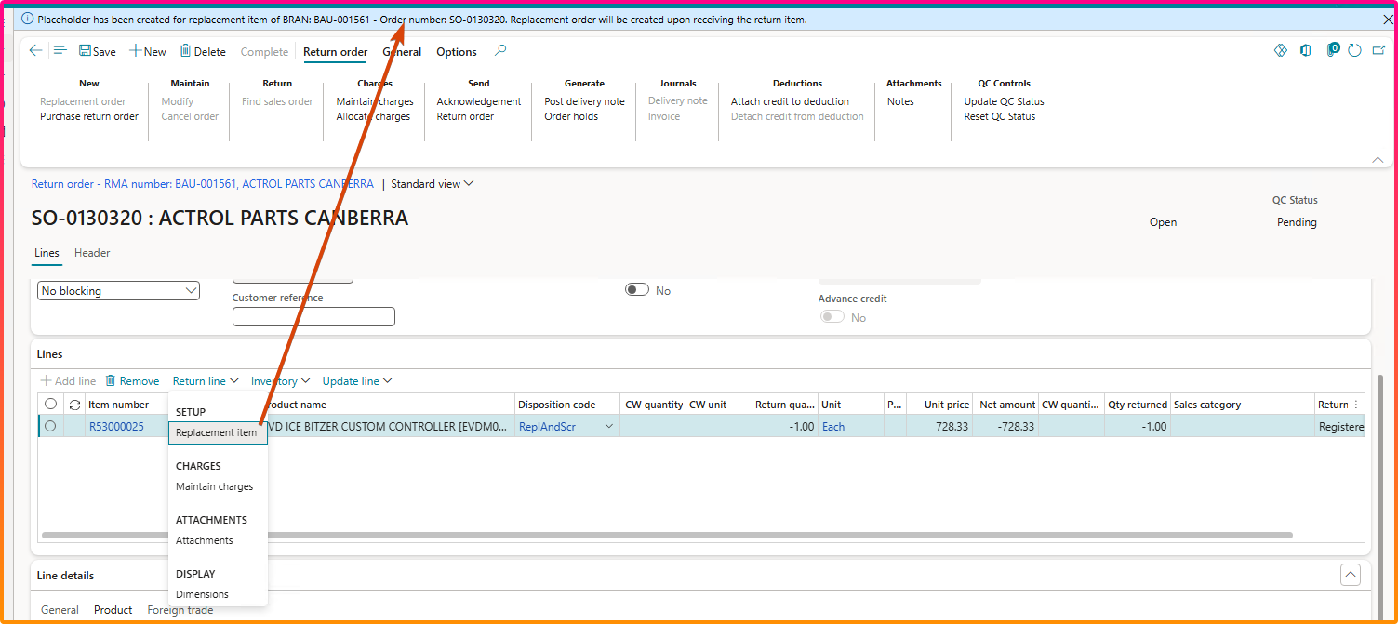

Upon posting delivery note on the BRAN, and if the BRAN is of type replacement, this will show up.

